**Ten Tenths – March 2025**

My excuse for a delayed March Newsletter is that whilst it has been winter in the UK, we, my wife Carolyn (your Hon. Secretary) and I, have been away on holiday to New Zealand to visit our son. NZ is impossible to sum up in a few photos but here goes:

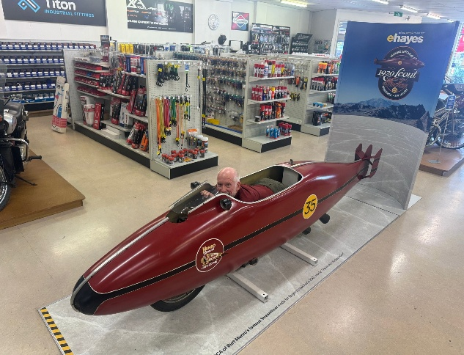

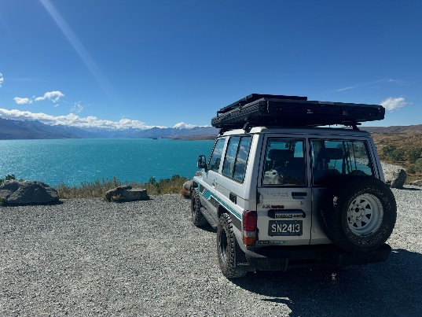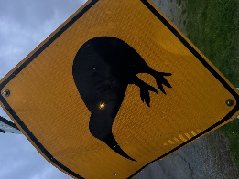

Warning for the lesser spotted Kiwi

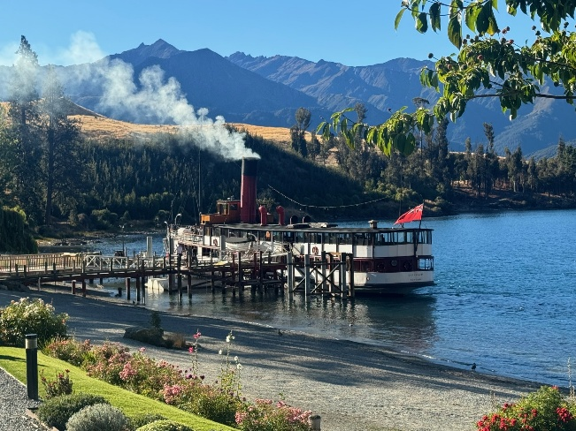 Munro Special replica at E. Hayes Invercargill. Toyota Landcruiser at Lake Pukaki

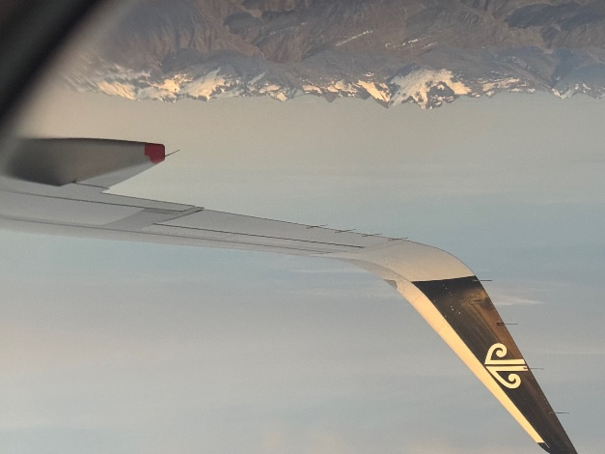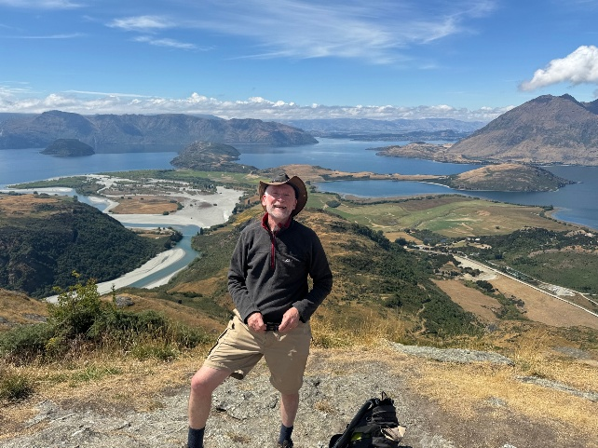Rocky Mountain Summit Lake Wanaka TSS Earnslaw on Lake Wakatipu

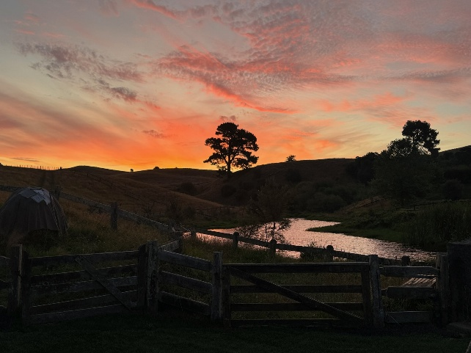Hobbiton Southern Alps

Spring in the UK is around the corner though and it’s time to pull the dust cover off your Healey, polish the plugs, and start racking up those miles. The Healey year starts with the Daffodil Event in Norfolk, that I organise with Carolyn, and I’m pleased some Southern Counties Members have signed up to this sold-out event. If you fancy a few nights away with like-minded Healey owners, enjoying the social side of what the Club offers, whether you come as a couple or single, this is a great event. As I mention in the ‘welcome note’ of the event information pack, it “is a largely informal event and we (the participants) are, to all intents and purposes, a large group of friends on a weekend away in our classic cars. If you are interested for next year, let me know and I can add your details to my no obligation list.

“**The Rearview Mirror**”. I would like to thank Graeme Brook, one of our long-standing members, for keeping pretty well every Ten Tenths Newsletter going back to 1985. This means we have the keys to the ‘tardis’ time machine and can look back into the past! Starting with this edition, I will select some snapshots, so we can appreciate how much, or little, has changed over the decades.

**March 1995**: The newsletter started with a plea from the Committee that “if you have any ideas about events you would like to see, let us know – or better still organise it yourself! The Committee will always support you with advice, publicity and funds, so don’t just sit there…..” There was mention about a Southern Counties Day ’95 at Penshurst Place (a location that is on the calendar for this year), an Egg Cup Treasure Hunt (remember I mentioned in the January letter that this trophy has now been re-purposed to the Daffodil Event Quiz?). Membership fees remained at £26 single and £27 joint after some “lively debate” at the February NEC meeting about a £5 increase, that Southern Counties “strongly opposed”.

**March 2005**: we were organising a Spring Lunch at the Victory Inn, Staplefield and Derek Edwards was advertising a Scatter Rally. The full calendar had no less than 20 entries. If we are to keep up, we need more support at grass roots level to fly our flag at local events – do get in touch if you would like to organise something and the Committee will lend whatever support we can.

**March 2015**: Steve Everest and Nigel Escolme were reporting on our Christmas lunch, held in January at the Victory Inn, and Steve was advertising the Spring Lunch to be held at the George and Dragon, Houghton (near Amberley). Do we want more lunches / dinners?

Do keep an eye on our Calendar of Events on the website. I will however highlight a few:

**Drive It Day (DID) 27th April**: Graeme Hogg has very kindly undertaken to organise the event this year. You should have already seen his Flyer with details of a new format, that we hope will inspire you to embrace the spirit of Drive It Day. In essence this year, rather than all meeting at one venue, we are planning to steer you towards three of our regular Noggin locations. You choose where (and when) to go and plan your own route. It could (and we hope will) be to more than one location, even all three! Please just let the Organiser of your planned destination (details in the Flyer) know you are coming and (approximately) when. We will award the DID Cup this year to the member who drives the greatest number of miles for the event on the day. That’s from home and back to home, to the nearest 1/10th, reported by midnight on Drive It Day by email to Graeme at [ahccomgh@proton.me](mailto:ahccomgh@proton.me). If we need a tiebreak, it will be the person reporting the most venues visited on the day. The trophy will be presented at a future event, perhaps the AGM. Please don’t forget to support NSPCC Childline through the purchase of rally plates, available to purchase at the Federation of British Historic Vehicle Clubs website https://www.driveitday.co.uk/shop.

**Staplefield Show Monday 26th May:** That’s the late May Bank Holiday and not long off. Nick Varlow is arranging for us to participate under our banners, and asks that if you wish to attend, you book through him, [nickvarlow@gmail.com](mailto:nickvarlow@gmail.com). He will make the block booking to the organisers. It's a lovely low key country show, one of our favourites, and the £3 cash entry fee on the day goes to local charity.

**Orchard Restorations and Southern Counties Open Day Saturday 7th June:** This ever-popular event is, of course, on our calendar. If you are planning to attend, Rob Law will appreciate advance notice: [info@orchardrestorations.co.uk](mailto:info@orchardrestorations.co.uk)

**Ladies Event Sunday 22nd June:** Michelle McDonough, [mg.mcdonough41@googlemail.com](mailto:mg.mcdonough41@googlemail.com) is organising our inaugural event for Lady Drivers and their Navigators. Meet for coffee at Hardy Engineering and then a planned drive through the Surrey Hills to the RAC Club at Epsom. Park on the grass in front of the Club, a tour of the Motor House, and cream tea. Price £35 per person. A few places are still available. So, Ladies, secure your place with Michelle before it’s too late, for what will be a very special event.

**Brooklands Saturday 9th August:** Save the date. We are making enquires of Brooklands Museum about a group visit, which should give us access to discounted entry tickets. If we get sufficient sign-up, we will arrange to enter through the Campbell Gate and park on the Finishing Straight in front of the Club House. I will let you know the details as soon as I know them.

**Capel Show Saturday 16th August:** Nick Varlow is booking a Healey stand. Members should book using the following link: <https://www.capelshow.co.uk/product/capel-classic-car-and-bike-show-2025/>. When booking, it is important you check the "Car Club" button and key in "Austin Healey Club" so the Organisers know you are part of our group.

**European Healey Meeting (EHM) in Holland 14-20 June 2027:** Pre-registration is now open. Whilst the date sounds a long way off, the organisers tell us the registration window is only open until the end of June 2025 (sic) and we are probably already into ‘wait list’ territory for the available 225 places, so popular is this event. Numerically, it would be like every Southern Counties member booking for and attending. Now there’s a thought! If you are interested in the EHM, and prepared for the approximate £4k event fee (plus travel expenses and spending money), don’t dawdle! Link: [europeanhealeymeeting.com](http://www.europeanhealeymeeting.com)

This is not an exhaustive list of forthcoming events, but highlights a few upcoming events where we have information for you.

**House Keeping**: The following posts need volunteers to fill them:

**Ten Tenths**: we are looking for anyone who is prepared to write a report on a Southern Counties event you attend, ideally with a photo or two you have taken (mobile phone photos are fine). This could either be for publication in Ten Tenths or Revcounter.

**Webmaster**: not as onerous as it sounds. Whilst someone with web skills would be our ideal candidate, we would be very happy to talk to someone offering more basic IT skills who would be prepared to just take on site maintenance / information updates.

**Hon. Secretary**: those who attended the AGM will know Carolyn kindly stepped into the role at very short notice. She is however keen to find a more permanent volunteer to take the role over.

In all cases, please contact me (details at the end of the Newsletter) or Carolyn on [carolyn@woodrow.eu.com](mailto:carolyn@woodrow.eu.com)

I mentioned in the previous issue that we were looking for old Club Trophies and I am pleased to report the Steering Wheel has come to light. Rob Law has undertaken to re-fix a plaque and give it a polish before we look to find new roles for this and other trophies that have come to light. Carolyn and I will try to visit some or all of the Southern Counties’ Noggin locations and bring the trophies along for people to see, and to make suggestions how they might be used. We will try to advertise any visits in advance through the appropriate Noggin Organiser.

At our **most recent Committee Meeting**, we heard from Nick Varlow, our NEC Director, that the Club is in negotiation with Peter James about a possible arrangement that will profit the Club whilst promoting the PJ classic car insurance program. The Club will circulate more information as soon as there is something to report. Nick is also working (at NEC level) to gather together technical Information from the 9 (yes, he tells me, 9) AHC websites and place them in one, prominent, indexed and searchable location. He has other plans, for example with our Member’s Map, once this goal is achieved.

We are also continuing to search for a possible North Surrey Noggin location, to supplement our current South Surrey location (The Surrey Oaks near Newdigate).

Second email addresses for our Joint Members remains work in progress.

The next Committee Meeting is scheduled for Monday 14th April. If you have any thoughts, or ideas, you would like raised at that meeting, please let me or our Secretary know, or talk to your local Noggin Organiser. Post that meeting, I will aim to get a further Newsletter published.

…and remember, as our NEC Director Nick likes to say, “Healeys are for Driving”.

Jonathan Woodrow

Chairman – Southern Counties

[Jonathan@woodrow.eu.com](mailto:Jonathan@woodrow.eu.com) - 07860 388077