**Ten Tenths – January 2025**

A Happy New Year to you all. May it include many miles of happy Healeying!

Many of you may recognize and, I hope, fondly remember the title of the Southern Counties’ News sheet that used to arrive tucked in with Revcounter: Ten Tenths. It stopped when Steve Everest moved to Eastern Centre and onto bigger things with Revcounter. It now seems appropriate to bring the title back to life in the form of this e-Newsletter, as it fulfills much of the intents of the old Ten Tenths whilst avoiding the (now) significant costs of a hard copy. I don’t guarantee an edition every month. Publication will be when there is news to share.

My wife asked me what Ten Tenths means. So, if you are curious, in motor racing terms it means pushing your car to the absolute physical limit. Perhaps not recommended on our roads today but, on the track…

If anyone out there reading this would like to take on the role of editor, I would be delighted to talk to you. The same applies to anyone who would like to offer Webmaster skills, either to look at development or to take on the maintenance role. Just email me back and we can arrange to chat.

I will start with a look back to the end of 2024. Post the AGM, a good number of Southern Counties members descended on Staplefield on the first Sunday in November; to watch the Veteran cars and even Penny Farthings attempt the annual run from London to Brighton. It’s always a sight and the village green was packed with parked cars and spectators. Many of our members retired to the Victory Inn for a late lunch, organised by Jeff Snell – “thank you, Jeff”. I know one or two attended the Classic Car Show at the NEC, Birmingham and one or two attended the National AGM near Warwick.

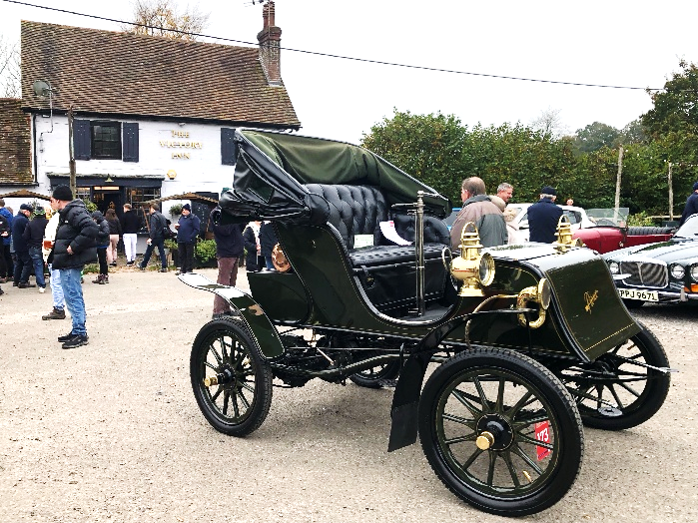

We are now looking forward to our events for 2025. Please always look at the Southern Counties webpage [ahc-sc.org.uk](https://ahc-sc.org.uk/) to check out the Events Calendar. I do however wish to highlight a few items:

For Drive-it Day (DID) on 27th April, Graeme Hogg is looking at the idea of basing this year’s event around our Noggin pubs. Whilst you might normally be content to just visit your own ‘local’ Noggin pub, the idea is that on DID you might visit another Noggin pub for a change or perhaps more than one other pub(?!). Afterall, the idea of Drive It Day is to get out there and drive your Healey. With this in mind, we are considering awarding the Derek Edwards Drive It Day Trophy to the person / couple who drive the most miles and visit the most Noggins on the day. As a tie break, we will credit the first to call in their results. All we would ask is that you notify the pub Noggin organiser of your intention to visit and approximately when. I hope we can circulate a bit more information in the near future, either via a future Newsletter or a dedicated communication.

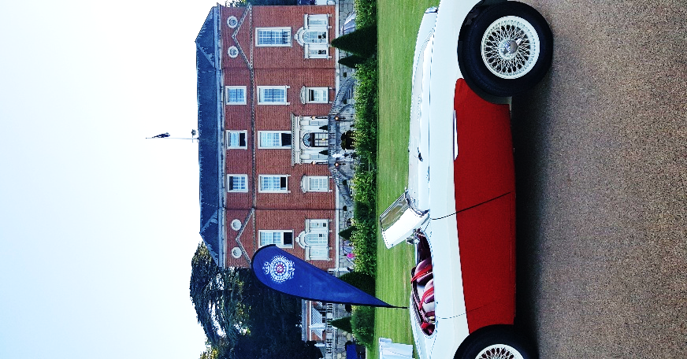

I also want to trailer a new event this year, specifically for our lady drivers and their lady navigators. This is being organised by Michelle McDonough and is scheduled for Sunday 22nd June, meeting at Hardy Engineering for morning coffee before a planned drive through the Surrey Hills, destination the RAC Club at Epsom. We hope you will be invited to park on the grass in front of the Club, tour the Motor House and enjoy a cream tea. Price to be advertised but I would recommend all ladies ‘save the date’ and apply quickly when formally advertised, as I imagine the available places will disappear quickly.

Some of you may be considering a visit to the Le Mans Classic (LMC). Did you know that Mark Knight, our National Marketing and Communications Director, is organising Club tickets direct from the event co-organizer, Peter Auto? If you contact Mark Knight [Mark@mknight.force9.co.uk](mailto:Mark@mknight.force9.co.uk), he can provide details and costs of what is available (parking in the Healey Club Area in the infield, personal admission ticket, paddock pass, grandstand ticket). You will need to register your interest with Mark by the end of January and book your own ferry tickets and accommodation, or approach one of the commercial organisations who market the event. However you book it, I can only recommend it. I have attended every running of the LMC since its creation in 2002 and will be there again this year. If you have any questions, please ask me.

Your Committee is looking at other ideas to supplement the events already advertised in the Calendar and we will keep you posted. We have just added the Staplefield Classic Car Show on Monday 26th May (contact Nick Varlow) and Classics at Penshurst on 17th August (contact Jonathan Woodrow) – with the latter, we will consider a Club Stand if there is sufficient interest, so do contact me. Our AGM is booked to take place at the Kings Head, Bessels Green (location of the North West Kent Noggin) on 9th September – 7pm to eat / 8pm AGM.

As items of ‘housekeeping’:

I have been asked to mention: we acknowledge not everyone wishes to receive Newsletters from me / emails from Noggin Organsiers etc. If you do NOT wish to receive such correspondence, log into the Member’s Area of the National Website and your personal details and delete your email address.

We are also looking into the possibility for couples who are Joint Members and have separate email addresses, that each receive their own copy of any general (i.e. non-membership-renewal) email communication. Once we know how we can make this work efficiently, we will let you know.

Your Committee is trying to identify the assets of Southern Counties. We have in safe keeping a two handled silver cup known as the Vice-President’s Trophy and a silver rose bowl trophy presented by (the late) Raymod Baxter. We also have a wooden Egg Cup (quiz) trophy that Derek Edwards used to present, now in use at the Daffodil Event. However, we are aware there were two more trophies: a wooden steering wheel, known as the “Austin Healey Club Inter-Team Challenge Trophy” and a 2 handled silver plate cup standing 220mm / 9” in height including base plinth. Does anyone know the whereabouts of either of these two trophies, or perhaps recalls when last they were awarded? It would be great to bring them all back into use. Please contact me with any memories you have, however foggy, either of how the trophies were awarded, or what happened to the two missing trophies. Thank you.

Does anyone have a library of back copies of the Ten Tenths news sheet they do not want, or that we can scan? I am thinking it might be fun to run a series of features ‘looking in the rear-view mirror’.

Your Committee last met on 16th December and one day I hope we will be publishing Minutes. We are not yet geared up to do this, so I thought instead I would instead list a few bullet points:

* We have now deposited our surplus / reserve funds in a 1-year bond to earn us interest
* Our NEC Director is working at National level to get our Member’s Map fully populated
* Our NEC Director is also working to consolidate the 7 National Technical databases and to make them searchable. This will supplement HealeyHelp.
* We are looking into the possibility of a supplemental Noggin to be located in North Surrey
* Your AHC Membership Card is downloadable from the Member’s Area of the National website
* Back copies of Revcounter are available on the National website, and will soon be searchable by text and title
* In certain circumstances, the DVLA accepts club records about cars. This makes it even more important you register the details for your car on the National website. This both improves the Club’s database and our credibility with the DVLA.
* Our former Chairman and NEC Director, Dave Colwell, has now been appointed Vice-Chairman of the National Executive Committee. He will be assisting the current chair, John Keener. This is in addition to continuing his role as National Safeguarding Officer. Please join me in congratulating Dave on his new appointment
* Did you know the Austin Healey Club (AHC) UK sponsors the Healey Museum in Holland and in return for this, any UK AHC member who visits (and shows their membership card) gets free admission
* Our own Rob Law of Orchard Restorations is looking to lend support in the running of the National Concours Competition
* Jeff Snell has taken over the running of the (South) Surrey Noggin from Keith Charie. Jeff’s contact details, along with the contact details of all our Noggin Organisers are on our website and in Revcounter

As you might surmise, your new Committee is VERY busy, both organizing itself and looking at what we currently offer to our members, and looking at what more we can offer or do better. Very much work in progress but hopefully you will be pleased with what you see and be encouraged to get involved in our events. As our NEC Director, Nick, likes to say: “Healeys are for Driving”.

Jonathan Woodrow

Chairman – Southern Counties

[Jonathan@woodrow.eu.com](mailto:Jonathan@woodrow.eu.com) - 07860 388077